1.18 For Each Controller with Regular Expression Extractor



This section will guide you to understand:

* How to perform For Each controller with regular expression extractor in JMeter

**Development Environment:**

* Apache Jmeter 5.1.1 Version
* JDK Runtime Environment 8.1

This guide has five subsections, namely:

1.18.1 Adding thread group

1.18.2 Adding For Each controller

1.18.3 Adding regular expression extractor

1.18.4 Adding debug post processor

1.18.5 Pushing the code to GitHub repositories

**Step 1.18.1:**  Adding thread group

* Open JMeter.
* Right click on Test Plan-->Add-->Threads-->Thread Group.

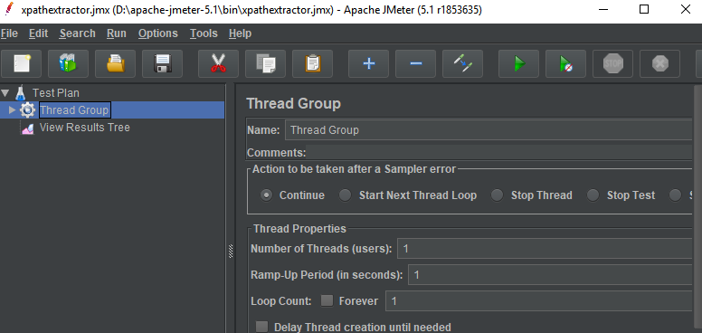

* Right click on Thread-->Add-->Sampler --> HTTP Request.

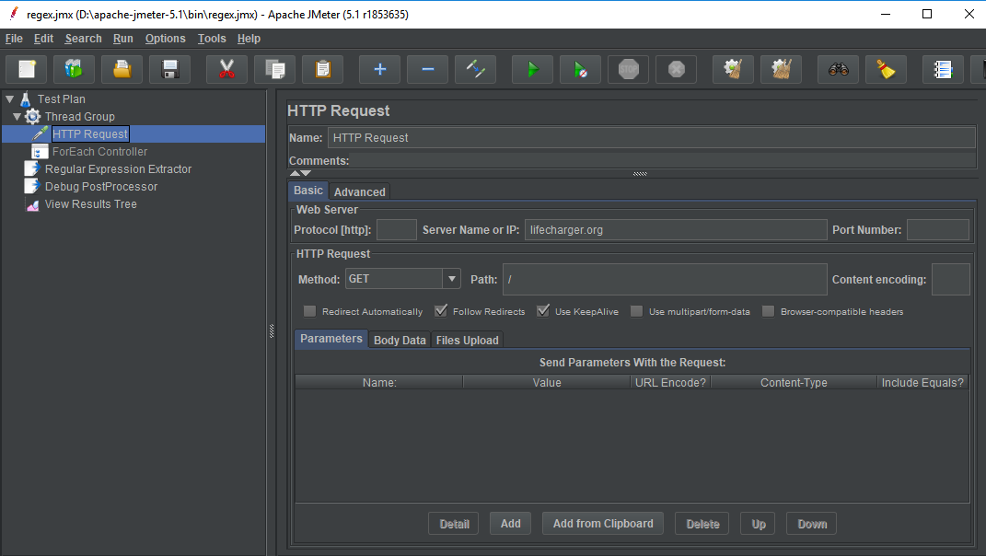

**Step 1.18.2:**  Adding For Each controller

* Right click on Thread Group-->Add -->Logic Controllers-->For Each Controller.

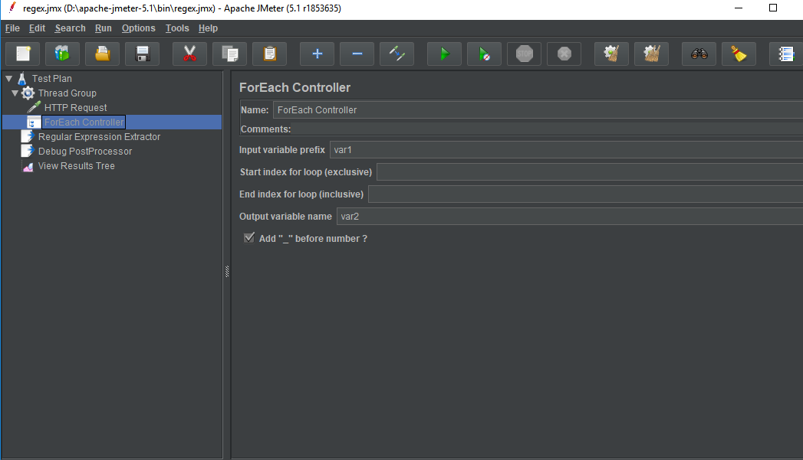

**Step 1.18.3:**  Adding regular expression extractor

* Right click on Thread Group-->Add -->PostProcessor-->Regular Expression Extractor.

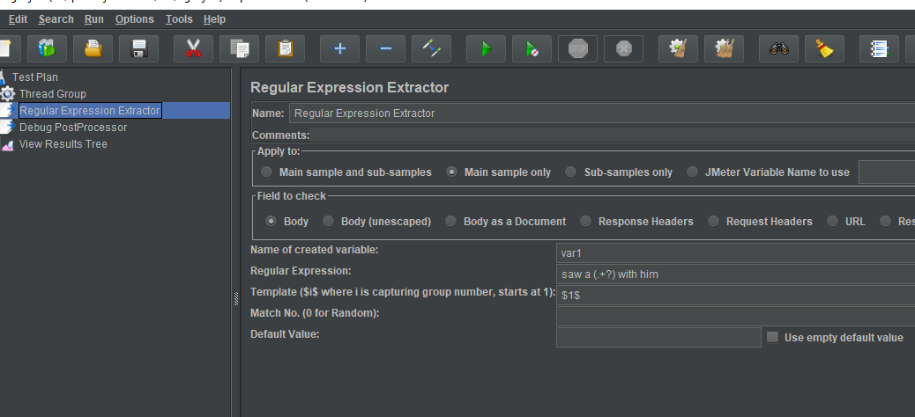

**Step 1.18.4:** Adding debug post processor

* Right click on Thread Group-->Add -->Post Processor-->Debug Post Processor.

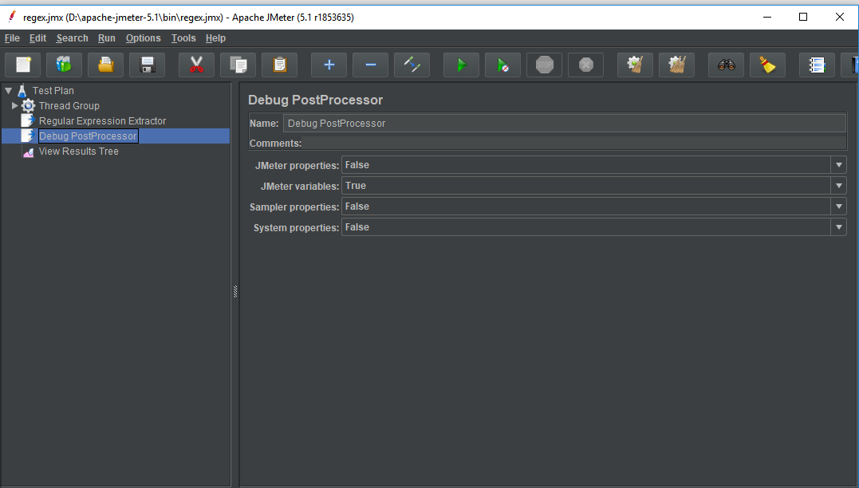

* Right click on Test Plan--> Add-->Listener-->View Result Tree.

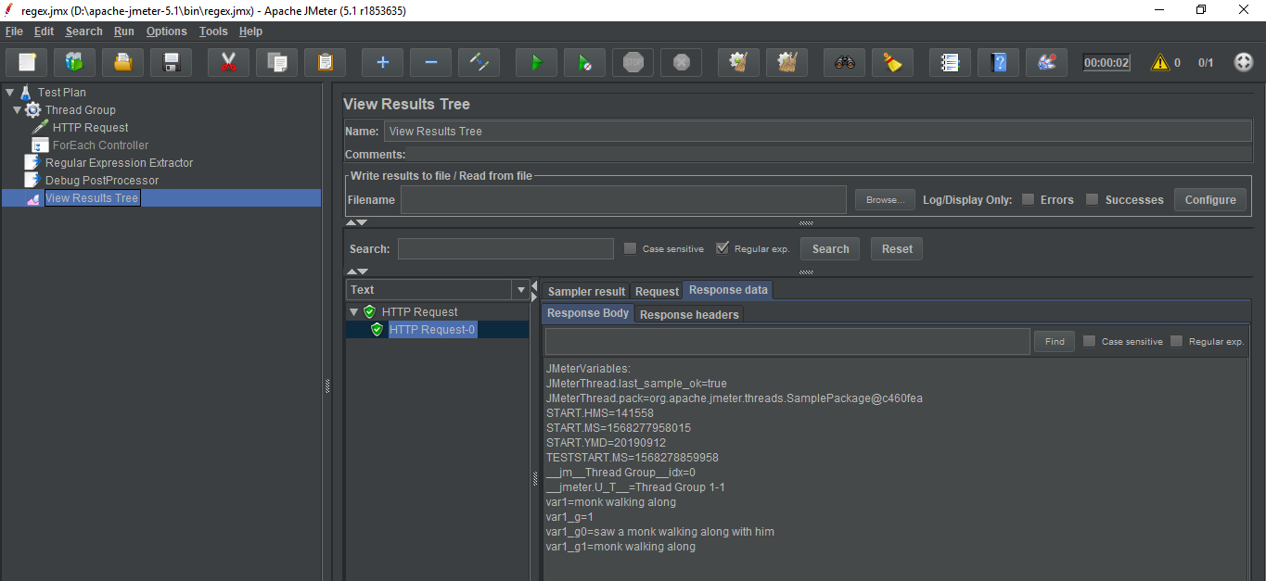

**Step 1.18.5:** Pushing the code to GitHub repositories

Open your command prompt and navigate to the folder where you have created your files.

cd <folder path>

Initialize your repository using the following command:

git init

Add all the files to your git repository using the following command:

git add . 

Commit the changes using the following command:

git commit . -m “Changes have been committed.”

Push the files to the folder you initially created using the following command:

git push -u origin master